**LAB 5**

**TASK 01,**

<https://leetcode.com/problems/valid-parentheses/submissions/1402748641?envType=problem-list-v2&envId=stack>

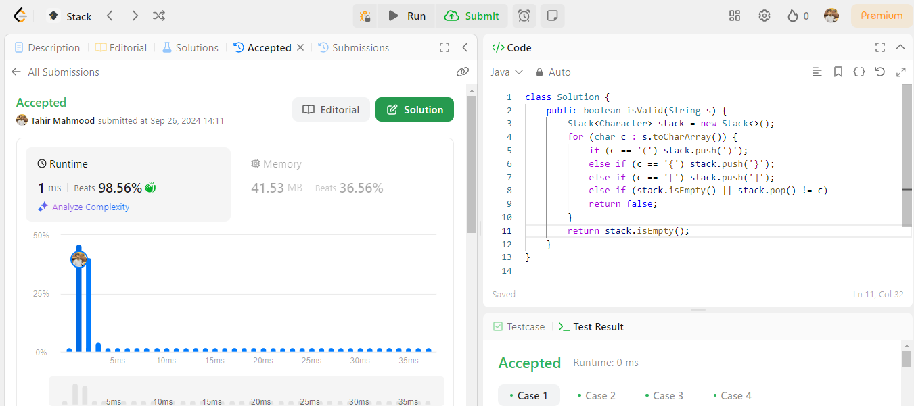

**TASK 2,**

<https://leetcode.com/problems/palindrome-linked-list/submissions/1402758991?envType=problem-list-v2&envId=stack>

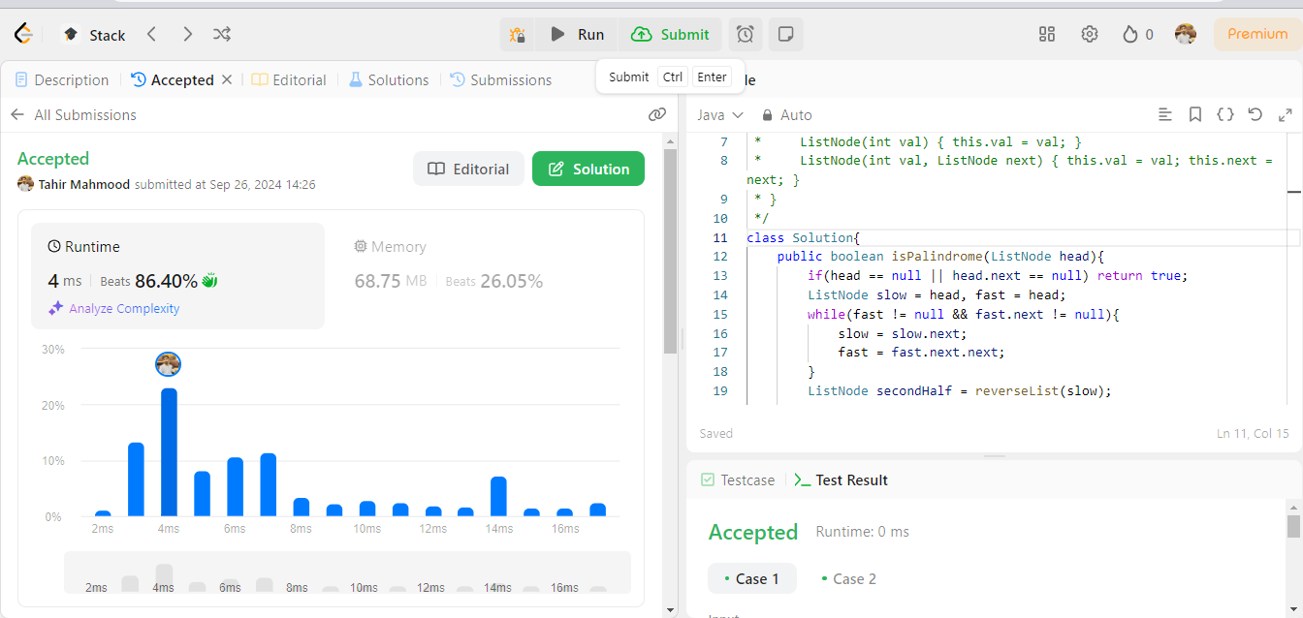

**Task 03**

<https://leetcode.com/problems/next-greater-element-i/submissions/1402766870?envType=problem-list-v2&envId=stack>

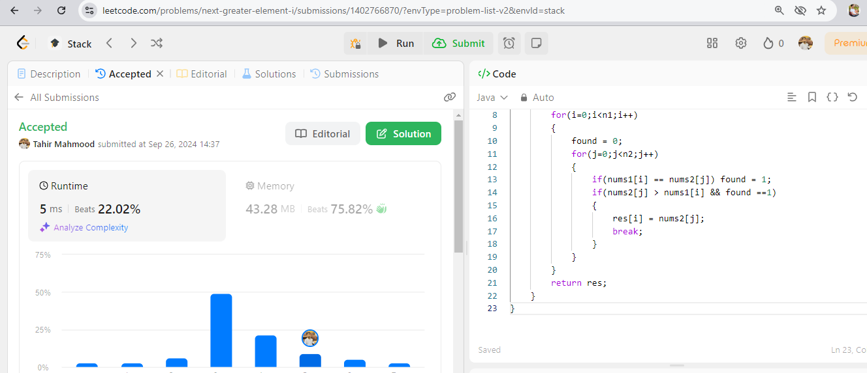

**Task 4**

<https://leetcode.com/problems/final-prices-with-a-special-discount-in-a-shop/submissions/1402768195?envType=problem-list-v2&envId=stack>

